**Farooq Ahmad Kuchay**

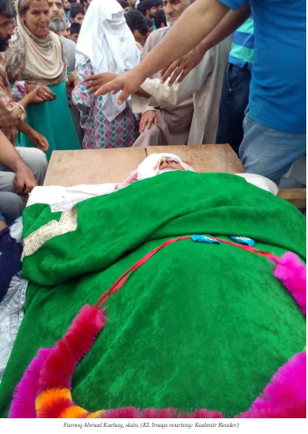

**About:** Sources said that unknown persons travelling in a vehicle opened fire on protesters at the highway village of lethpora near Pampore in south Kashmir’s Pulwama district when protesters hurled stones on the vehicle.

One protester Farooq Ahmad Kuchay died on the spot while another was injured. It was not immediately known who were travelling in the vehicle. locals said the vehicle belonged to some State official who was travelling with his security guards. There was no word from the Government over the incident.

**Murdered on:**02 Aug 2016

**Attack details:** Farooq Ahmad Kuchay,32, son of Ghulam Nabi Kuchay was killed by police security guard.

**Reason to him target:** The PSO allegedly opened fire after the vehicle was circled by protesters. One civilian, identified as Farooq Ahmad Kuchay.

**Occupation: :** Farooq is a truck driver who was to be married next month. He had returned home yesterday.

**URL:** <https://kashmirlife.net/day27-one-tortured-one-killed-tragedy-of-lethpora-family-113641/>

<http://www.knskashmir.com/news.aspx?news=Civilian-killed-in-Lethpora-firing-9768>